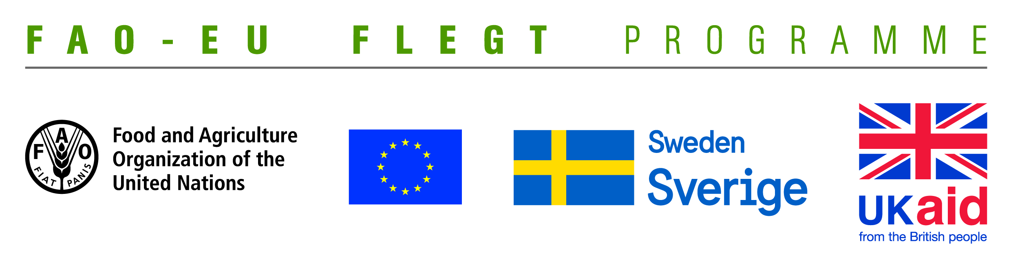
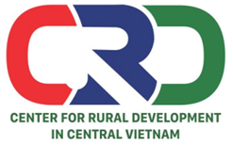

TERMS OF REFERENCE (TOR)

Project name | Supporting small business holders comply with the LD requirements in order to effectively participate in national and global legal timber supply chains
Job Title | Conducting final project evaluation
Recruiting Organization | Centre for Rural Development in Central Vietnam (CRD)
Working location | Quang Tri and Dong Nai provinces
Time | From January to February 2020

- Background information
Centre for Rural Development in Central Vietnam (CRD) is implementing the project “Supporting small business holders comply with the LD requirements in order to effectively participate in national and global legal timber supply chains” funded by EU-FAO FLEGT Programme via the Food and Agriculture Organization of the United Nations (FAO). The project has been implemented since March 15, 2014. It will end on December 31 this year. It covers 02 provinces: Quang Tri and Dong Nai. The project aims to supporting small business holders to comply with the legal requirements, Vietnam Timber Legality Assurance System and Organizations Classification System requirements in order to effectively participate in national and global legal timber supply chains. Its specific objectives are:
- To understand the technical capacity needs of provincial level stakeholders such as business associations, civil society organizations (CSOs), and provincial Forest Protection Department (FPD) to provide support to small business holders;
- To increase CSOs and business associations capacity to provide technical support to small business holders; and
- To develop an approach for future independent/participatory monitoring of Vietnam Timber Legelity Assurance System (VNTLAS) and Organization Classification System (OCS) implementation by CSOs and business associations.
It was expected that the project would obtain four outcomes: (i) The Service Provider will produce, achieve or deliver the following outputs or outcomes; (ii) Rapid assessment for better understanding of capacity-building needs of local stakeholders at provincial level conducted and assessment methodology validated; (iii) Capacity of CSOs and other local partner organizations to provide targeted technical support to micro-enterprises for Legality Definition (LD) compliance strengthened and tested; (iv) CSOs and local associations have the capacity to undertake independent/participatory monitoring of VNTLAS and OCS implementation; (v) Monitoring, evaluation and visibility framework developed.
After almost 2 years implementation of the project, CRD is looking for two consultants with professional knowledge and good experience to conduct final evaluation for this project.
- Objective of the evaluation
- To assess the level of achievement of objectives, targets and expected outcomes of the project basing on the following criteria:
- Efficiency: Assess the level of achievement of objectives and expected results of the project through the outputs/outcomes obtained.
- Relevance: Assess whether the outputs/outcomes, overall objective and specific ones, approaches/implementation methods of the project suit/meet the needs of the project beneficiaries and stakeholders and consist with existing policies
- Performance: Compare the outcomes with the resources (time, human, material and financial ones) used by the project.
- Impacts: Assess the impacts of the project on the direct and indirect beneficiaries, including possitive impacts and negative ones (if any).
- Sustainability: Assess the sustainability of the project outputs/outcomes as well as the feasibility for the continuation of project activities when it runs out of external financial support.
- To provide recommendations and proposals to enhance the project sustainability using internal resources.
- Tasks and duties
- Preparation: conducting desk study, developing technical proposal
- Data collection: Conducting interviews and group discussions with relevant agencies, CSOs and wood enterprises.
- Writing report: Synthesizing information, processing data, writing and finalizing report
- Presenting results of project valuation at a project closing workshop.
- Deliverables
- 01 technical proposal including data collection meethod and tools
- 01 project evaluation report
- 01 presentation presented at the project closing workshop
- Qualifications
- At least Master degree in forestry, development studies, project management and other related fields.
- Good understanding of community forestry issues, timber trade, VPA-FLEGT, LD, VNTLAS, etc.
- At least 05 years of experience in implementation of project evaluation.
- Having experiences in working with NGOs and wood enterprises is prefered.
- Good skills in analyzing, synthesizing information and writing report.
Interested candidates are invited to send CVs via email no later than 22 January, 2020: namnv@crdvietnam.org with cc huongnl@crdvietnam.org

