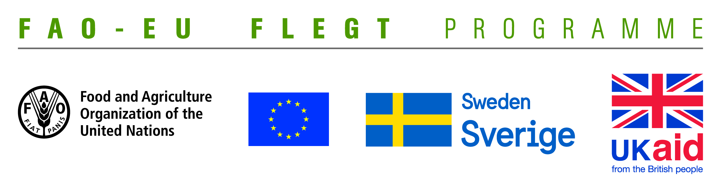
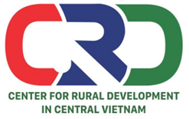

TERMS OF REFERENCE (TOR)

Project name | Supporting small business holders comply with the LD requirements in order to effectively participate in national and global legal timber supply chains
Job Title | Looking for a consultant to facilitate and moderate two ToT training courses for local CSOs on how to support business close the compliance gaps identified during the capacity needs assessment
Contracting Organization | Centre for Rural Development in Central Vietnam (CRD)
Location | Quang Tri and Dong Nai provinces
Time | From November to December 2019

- Background information
Centre for Rural Development in Central Vietnam (CRD) is implementing the project “Supporting small business holders comply with the LD requirements in order to effectively participate in national and global legal timber supply chains” funded by EU-FAO FLEGT Programme via the Food and Agriculture Organization of the United Nations (FAO). The project aims to supporting small business holders to comply with the legal requirements, Vietnam Timber Legality Assurance System and Organizations Classification System requirements in order to effectively participate in national and global legal timber supply chains.
Under the project, two ToT training courses will be carried out in Quang Tri and Dong Nai provinces. Participants of the training comes from local CSOs; state forestry agencies, enterprises and household business. The purpose of the training course is to equipe participants with knowledge on legal timber requirements accordance with VPA-FELGT as well as Vietnam legislation; help them identify and close gaps of actors involved in certain supply chains. CRD is looking for aconsultant with professional knowledge and good experience to facilitate and moderate for two ToT training courses in Quang Tri and Dong Nai provinces.
- Tasks and duties
- Prepare ToT training agenda
- Prepare ToT training evaluation form
- Prepare the training materials including following contents:
- The legal provisions on legal timber: Packing list; Sales contract or equivalant; Invoice as required by the Ministry of Finance; Declaration for imported timber products; Plant quarantine certificate for round timber, sawn timber, pallet, sawdust; A Self-declaration demonstrating due diligence on the legality of timber.
- Storage and management of documents, records proving legal timber: Records of circulation; Records of production; Records of trade, import and export of wood and wood products.
- The legal provisions on labor: Labour Contract; Labour Insurance (Social Insurance and Health Insurance); Labor safety / labor protection.
- Legal provisions on environmental protection, fire protection: Environmental protection plan; Commitment on environmental sanitation; Design and appraisal on fire protection.
- Facilitate and moderate the two trainings
- Synthesize information and write post training report
- Deliverables
- A ToT training agenda
- A ToT training evaluation form
- Traing materials and hand-outs
- Two post-trainings reports
- Qualifications
- At least Master degree in forestry, business management, project management or development related fields.
- Good knowledge on forestry laws and VPA/FLEGT, LD, VNTLAS related issues.
- At least 5 years of working experience in facilitating and moderating workshops and trainings
- Experience in working with NGOs, CSOs and timber processing enterprises is prefered.
- Good skills in stimulating group discussions.
- Good skills in synthesizing, processing information and writing report.
- Ability to work independently and in a team.
- Excellent verbal and written communication skills in both English and Vietnamese.
Interested candidates are invited to send CVs via email no later than 18 November, 2019: namnv@crdvietnam.org with cc huongnl@crdvietnam.org

