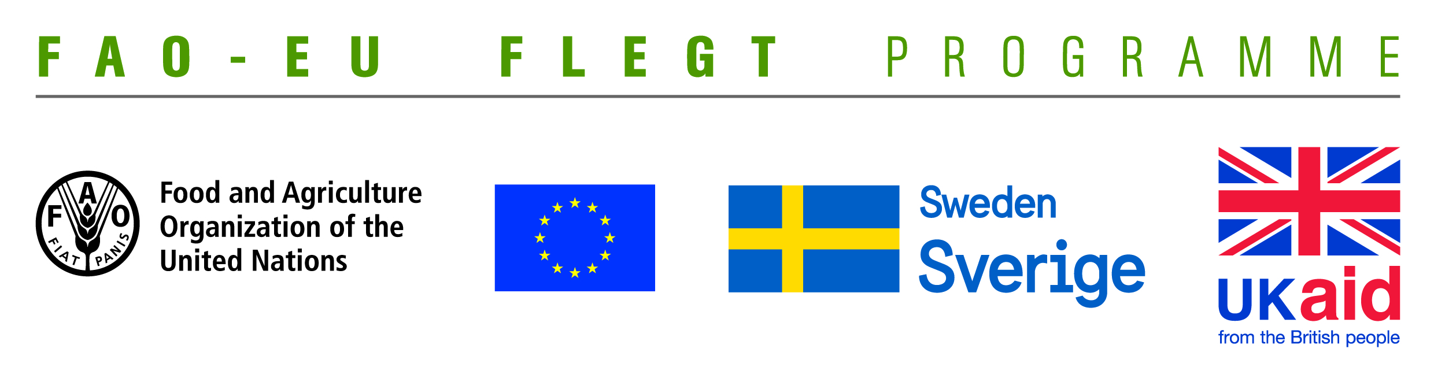
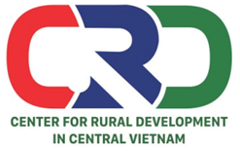

TERMS OF REFERENCE (TOR)
Project name | Supporting small business holders comply with the legality definition requirements in order to effectively participate in national and global legal timber supply chains
Job Title | Looking for a consultant team to make a film documenting project‘s technical supporting activities for small wood processing enterprises in Quang Tri and Dong Nai provinces
Contracting Organization | Centre for Rural Development in Central Vietnam (CRD)
Location | Thua Thien Hue
Time | From January to September 2019

- Background information
The EU-FAO FLEGT Programme provides financial assistance for the implementation of Voluntary Partnership Agreement on Forest Law Enforcement, Governance and Trade (VPA/FLEGT) in the countries. This programme aims improving forest management and protection, capacity building and technical support through projects in forestry area. The EU-FAO FLEGT Programme supports Vietnam on developing Vietnam Timber Legality Assurance System (VNTLAS), reinforcing the commitment of the wood processing industry in the region to create a legal source of wood, harvest timber in a sustainable way and focusing on the capacity building activities for relevant agencies and stakeholders to implement effectively VPA/FLEGT agreements.
Centre for Rural Development in Central Vietnam (CRD) implements the project titled “Supporting small business holders comply with the LD requirements in order to effectively participate in national and global legal timber supply chains” funded by the Food and Agriculture Organization of the United Nations (FAO). The project aims supporting small business holders to comply with the legal requirements, Vietnam Timber Legality Assurance System and Organizations Classification System requirements in order to effectively participate in national and global legal timber supply chains. Under the project, CRD will coordinate with Center for Education and Development (CED), Center for People and Environment (COPE) and other local partner organizations including: Forestry management agencies, Timber Association and other civil social organizations (CSOs) to implement activities in Quang Tri and Dong Nai Province and produce, achieve or deliver the following outcomes:
Outcome 1: Rapid assesment for better under standing of capacity building needs of local stakeholders at provincial level conducted and assessment methodology validated.
Outcome 2: Capacity of CSOs and other local partner organizations to provide targeted technical support to micro-enterprises for Legality Definition compliance strengthened and tested.
Outcome 3: CSOs and local associations have the capacity toundertake independent/participatory monitoring of VNTLAS OCS implementation.
Outcome 4: Monitoring, evaluation and visibility framework developed.
Under the project, a documentary film will be made to document project‘s technical supporting activities for small wood processing enterprises in Quang Tri and Dong Nai provinces. CRD is looking for a consultant team with professional knowledge and good experience to make the film.
- Tasks and duties
- Collecting and studying documents related to the project and VPA/FLEGT, VNTLAS/OCS,...
- Building up and finalizing film script according to project’s requirements.
- Building up a detail plan for recording, editing and other specialized activities.
- Building up plan to interview agencies in forestry sector, relevant agencies and wood processing enterprises.
- Taking part in project’s training courses, technical support activities and other project’s activitiesto collect information for the film.
- Conducting record in the field, writing, taking note to collect data and information for film making.
- Completing the documentary film and collecting comments/feedback from stakeholders as well as project to finalize.
- Broadcasting the documentary film for one time and replay for one time on a channel of Viet Nam Television (VTV).
- Deliverables
- 01 film script
- 01 detailed plan for recording and interviewing relevant agencies
- 01 documentary film broadcasted on a channel of Viet Nam Television (VTV)
- 10 DVD copies of the documentary film.
- Qualifications
- Minimum five years experience in the field of public information and communication for the development project.
- Background in development studies, communications, journalism or equivalent.
- Good knowledge on forestry laws and VPA/FLEGT, LD, VNTLAS related issues.
- Have experiences in film script writing, film recording, editing TV programme in forestry sector.
- Keen understanding of forestry governance issues in Vietnam.
- Excellent verbal and written communication skills in both English and Vietnamese.
- Ability to work independently and in a team.
Interestedcandidates are invited to send CVs via email no later than 16 January, 2019: namnv@crdvietnam.org with cc huongnl@crdvietnam.org

