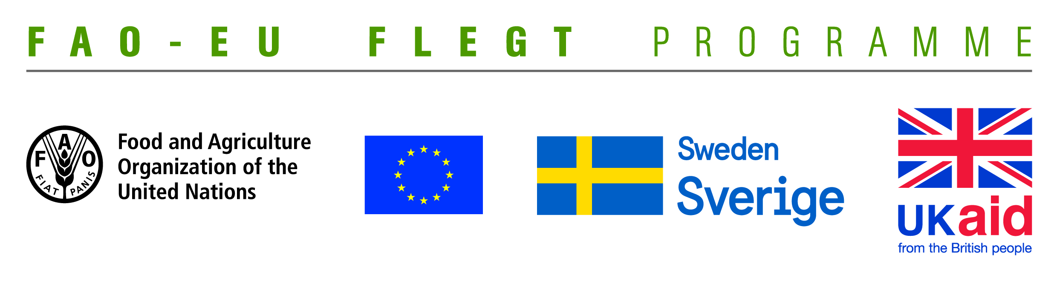
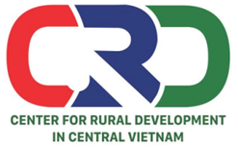

TERMS OF REFERENCE (TOR)
Project name | Supporting small business holders comply with the LD requirements in order to effectively participate in national and global legal timber supply chains
Job Title | Looking for a consultant to facilitate and moderate launching workshop to provide feedback on the assessment result to provincial partners and VNFOREST
Contracting Organization | Centre for Rural Development in Central Vietnam (CRD)
Location | Thua Thien Hue
Time | From August to September 2018

- Background information
The EU-FAO FLEGT Programme provides financial assistance for the implementation of Voluntary Partnership Agreement on Forest Law Enforcement, Governance and Trade (VPA/FLEGT) in the countries. This programme aims improving forest management and protection, capacity building and technical support through projects in forestry area. The EU-FAO FLEGT Programme supports Vietnam on developing Vietnam Timber Legality Assurance System (VNTLAS), reinforcing the commitment of the wood processing industry in the region to create a legal source of wood, harvest timber in a sustainable way and focusing on the capacity building activities for relevant agencies and stakeholders to implement effectively VPA/FLEGT agreements.
Centre for Rural Development in Central Vietnam (CRD) implements the project titled “Supporting small business holders comply with the LD requirements in order to effectively participate in national and global legal timber supply chains” funded by the Food and Agriculture Organization of the United Nations (FAO). The project aims supporting small business holders to comply with the legal requirements, Vietnam Timber Legality Assurance System and Organizations Classification System requirements in order to effectively participate in national and global legal timber supply chains. Under the project, CRD will coordinate with Center for Education and Development (CED), Center for People and Environment (COPE) and other local partner organizations including: Forestry management agencies, Timber Association and other civil social organizations (CSOs) to implement activities in Quang Tri and Dong NaiProvince and produce, achieve or deliver the following outcomes:
Outcome 1: Rapid assesment for better under standing of capacity building needs of local stakeholders at provincial level conducted and assessment methodology validated.
Outcome 2: Capacity of CSOs and other local partner organizations to provide targeted technical support to micro-enterprises for Legality Definition compliance strengthened and tested.
Outcome 3: CSOs and local associations have the capacity toundertake independent/participatory monitoring of VNTLAS OCS implementation.
Outcome 4: Monitoring, evaluation and visibility framework developed.
Under the project, a launching workshop will be carried out with participants from goverment forestry agencies, NGOs, civil society organizations and wood enterprises. This workshop aims at introducing about the project, taking consultation on a report on need assessment with wood enterprises which has conducted in Quang Tri and Dong Nai under this project, and making project work plan. CRD is looking for a consultant with professional knowledge and good experience to facilitate and moderate the workshop.
- Tasks and duties
- Prepare workshop agenda
- Prepare workshop evaluation form
- Review and give comments on materials and presentations
- Facilitate and moderate a one – day workshop
- Synthesize information and write report
- Deliverables
- A one – day workshop agenda
- A workshop evaluation form
- A post - workshop report
- Qualifications
- At least Master degree in forestry, business management, project management or development related fields.
- Good knowledge on forestry laws and VPA/FLEGT, LD, VNTLAS related issues.
- At least 5 years of working experience in facilitating and moderating workshops and trainings
- Experience in workingwith NGOs, CSOs and timber processing enterprises is prefered.
- Good skills in stimulating group discussions.
- Good skills in synthesizing, processing information and writing report.
- Ability to work independently and in a team.
- Excellent verbal and written communication skills in both English and Vietnamese.
Interested candidates are invited to send CVs via email no later than 20 August, 2018: namnv@crdvietnam.org with cc huongnl@crdvietnam.org

