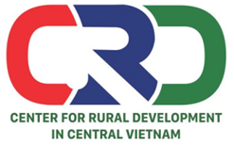
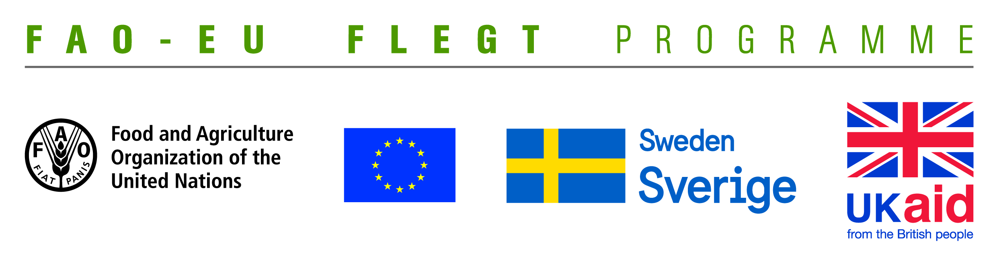

TERMS OF REFERENCE (TOR)
Project name | Supporting small business holders comply with the LD requirements in order to effectively participate in national and global legal timber supply chains
Job Title | Enumerators for a survey with wood business holders in Quang Tri and Dong Nai provinces
Contracting Organization | Centre for Rural Development in Central Vietnam (CRD)
Time | From August to September 2018

- Introduction
Centre for Rural Development in Central Vietnam (CRD) implements the project titled “Supporting small business holders comply with the LD requirements in order to effectively participate in national and global legal timber supply chains” funded by the Food and Agriculture Organization of the United Nations (FAO). The project aims at supporting small business holders to comply with the legal requirements, Vietnam Timber Legality Assurance System (VNTLAS) and Organizations Classification System (OCS) requirements in order to effectively participate in national and global legal timber supply chains.
Under the project, a rapid assessment of capacity building need will be carried out, which aims at understanding the technical capacity needs of provincial level stakeholders such as business associations, local civil society organizations and Forest Protection Departments in providing supports for small business holders.
For implementation of the activity, CRD is seeking for 20 enumerators to conduct a survey with wood business holders in Quang Tri and Dong Nai provinces.
- Scope of works
- Participating in training on survey methodology and tool.
- Conducting interviews with wood business holders using designed questionnaire.
- Entering data into Excel file for a database.

- Qualification and competency requirements
- At least Bachelor degree in forestry, community development or related fields.
- Good experience with surveys and interviews.
- Good knowledge on VPA/FLEGT, timber trade or related fields will be prefered.
- Ability to independent and group work.
- Be available for survey that is planned in Quang Tri and Dong Nai from August to September 2018.
- Candidates living in Quang Tri and Dong Nai will be prefered.

Interested candidates are invited to send CVs via email no later than 30 July, 2018 to namnv@crdvietnam.org

