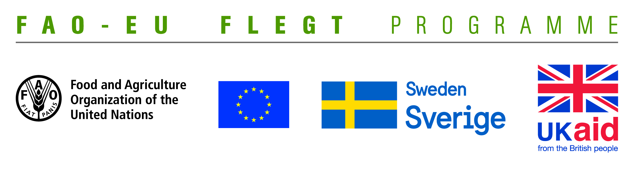
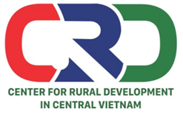

TERMS OF REFERENCE (TOR)
Project name | Supporting small business holders comply with the LD requirements in order to effectively participate in national and global legal timber supply chains
Job Title | Looking for a consultant to facilitate and moderate workshops and trainings
Contracting Organization | Centre for Rural Development in Central Vietnam (CRD)
Location | Thua Thien Hue
Time | From June 2018 to September 2019

- Background information
The EU-FAO FLEGT Programme provides financial assistance for the implementation of Voluntary Partnership Agreement on Forest Law Enforcement, Governance and Trade (VPA/FLEGT) in the countries. This programme aims improving forest management and protection, capacity building and technical support through projects in forestry area. The EU-FAO FLEGT Programme supports Vietnam on developing Vietnam Timber Legality Assurance System (VNTLAS), reinforcing the commitment of the wood processing industry in the region to create a legal source of wood, harvest timber in a sustainable way and focusing on the capacity building activities for relevant agencies and stakeholders to implement effectively VPA/FLEGT agreements.
Centre for Rural Development in Central Vietnam (CRD) implements the project titled “Supporting small business holders comply with the LD requirements in order to effectively participate in national and global legal timber supply chains” funded by the Food and Agriculture Organization of the United Nations (FAO). The project aims supporting small business holders to comply with the legal requirements, Vietnam Timber Legality Assurance System and Organizations Classification System requirements in order to effectively participate in national and global legal timber supply chains. Under the project, CRD will coordinate with Center for Education and Development (CED), Center for People and Environment (COPE) and other local partner organizations including: Forestry management agencies, Timber Association and other civil social organizations (CSOs) to implement activities in Quang Tri and Dong Nai Province and produce, achieve or deliver the following outcomes:
Outcome 1: Rapid assesment for better understanding of capacity building needs of local stakeholders at provincial level conducted and assessment methodology validated.
Outcome 2: Capacity of CSOs and other local partner organizations to provide targeted technical support to micro-enterprises for Legality Definition compliance strengthened and tested.
Outcome 3: CSOs and local associations have the capacity to undertake independent/participatory monitoring of VNTLAS OCS implementation.
Outcome 4: Monitoring, evaluation and visibility framework developed.
To implement the proposed activities under the project, CRD is currently looking for a consultant with sufficient qualifications and ability to facilitate and moderate workshops and trainings. The successful candidate will work directly with Project Coordinator and Team Leader who come CRD.
- Qualification and competencies required
- At least Master degree in forestry, development studies or related fields.
- Good knowledge on forestry laws and VPA/FLEGT, LD, VNTLASrelated issues.
- At least 5 years of working experience in facilitating and moderating workshops and trainings
- Experience in working with NGOs, CSOs and timber processing enterprises is prefered.
- Good at developing training materials for goup of diverse trainers
- Good skills to promote and operate group discussions.
- Good skills in synthesizing, processing information and writing report.
- Ability to work independently and in a team.
- Good at speaking and writing in English is prefered.
- Overall responsibilities
- Set up agenda of meetings, workshops and trainings, prepare evaluation forms and compile post-training and workshop reports
- Facilitate and take notes for meetings and workshops and provide trainings on organization classification system, VNTLAS, monitoing, and other VPA-FLEGT related issues.
- Work with other consultants in developing training materials and in preparing presentations at workshops/meetings.
- Support in developing criteria and selecting members of the CSO network to provide techincal assisstance and trainngs for timber enterprises.
- Synthesize feedbacks and draft recommendations to VNFOREST and Forest Protection Department.
Interested candidates are invited to send CVs via email no later than 18 June, 2018: namnv@crdvietnam.org with cc hoangtq@crdvietnam.org and huongnl@crdvietnam.org

