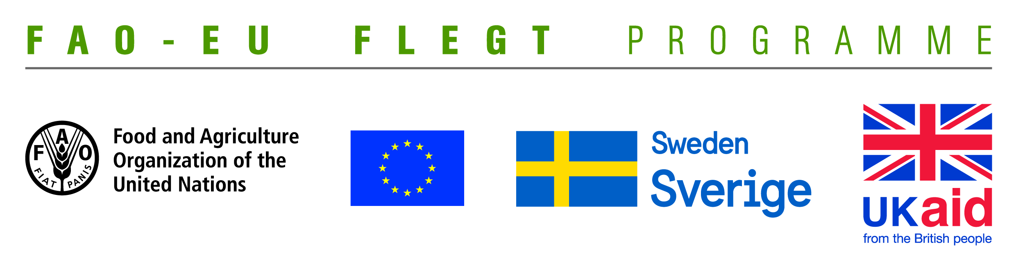
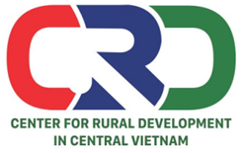

TERMS OF REFERENCE (TOR)
Project name | Supporting small business holders comply with the LD requirements in order to effectively participate in national and global legal timber supply chains
Job Title | Looking for a consultant to provide technical support for households and business
Contracting Organization | Centre for Rural Development in Central Vietnam (CRD)
Location | Thua Thien Hue
Time | From May 2018 to September 2019
- Background information
The EU-FAO FLEGT Programme provides financial assistance for the implementation of Voluntary Partnership Agreement on Forest Law Enforcement, Governance and Trade (VPA/FLEGT) in the countries. This programme aims improving forest management and protection, capacity building and technical support through projects in forestry area. The EU-FAO FLEGT Programme supports Vietnam on developing Vietnam Timber Legality Assurance System (VNTLAS), reinforcing the commitment of the wood processing industry in the region to create a legal source of wood, harvest timber in a sustainable way and focusing on the capacity building activities for relevant agencies and stakeholders to implement effectively VPA/FLEGT agreements.
Centre for Rural Development in Central Vietnam (CRD) implements the project titled “Supporting small business holders comply with the LD requirements in order to effectively participate in national and global legal timber supply chains” funded by the Food and Agriculture Organization of the United Nations (FAO). The project aims supporting small business holders to comply with the legal requirements, Vietnam Timber Legality Assurance System and Organizations Classification System requirements in order to effectively participate in national and global legal timber supply chains. Under the project, CRD will coordinate with Center for Education and Development (CED), Center for People and Environment (COPE) and other local partner organizations including: Forestry management agencies, Timber Association and other civil social organizations (CSOs) to implement activities in Quang Tri and Dong Nai Province and produce, achieve or deliver the following outcomes:
Outcome 1: Rapid assesment for better understanding of capacity building needs of local stakeholders at provincial level conducted and assessment methodology validated.
Outcome 2: Capacity of CSOs and other local partner organizations to provide targeted technical support to micro-enterprises for Legality Definition compliance strengthened and tested.
Outcome 3: CSOs and local associations have the capacity to undertake independent/participatory monitoring of VNTLAS OCS implementation.
Outcome 4: Monitoring, evaluation and visibility framework developed.
To implement the proposed activities under the project, CRD is currently looking for a consultant to work on part-time basis (02 days per month on total 18 months) to conduct technical support activities for households and business as needed on Legality Definition (LD), Vietnam Timber Legality Assurance System (VNTLAS) and Organization Classification System (OCS) in Quang Tri and Dong Nai provinces. The successful candidate will report to the Project team leader and work with CRD’s team.
- Qualification and competencies required
- University or master degree in forestry, timber processing, business/enterprise management or related fields.
- Good knowledge on VPA/FLEGT, LD, VNTLAS, community forestry and timber trade.
- At least 03 years of work experience with community and small medium enterprises.
- Ability to work independently and in a team.
- Skillful to promote and operate group discussion.
- Skillful to analyze, synthesize information and write reports.
- Overall responsibilities
Consultant have responsibility on guidance and providing technical support for households and business as needed of LD, VNTLAS, OCS in Quang Tri and Dong Nai provincesfrom April 2018 to September 2019 with the following contents:
- Provide guidance on arranging timber origin records to households and enterprises.
- Improve the management ofrecordsfor small medium enterprises to comply with LD and VNTLAS requirements.
- Develop a legal timber records management system and recordsstorage system
- Implement technical support and guidance activities on legal timber records management system and recordsstorage system

Interestedcandidatesare invited to send CVs via email no later than 28 May, 2018: namnv@crdvietnam.org with cc hoangtq@crdvietnam.org and huongnl@crdvietnam.org

