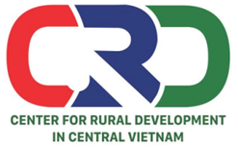
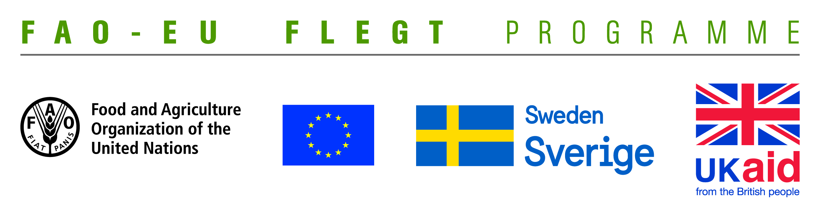

TERMS OF REFERENCE (TOR)
Project name | Supporting small business holders comply with the LD requirements in order to effectively participate in national and global legal timber supply chains
Job Title | Looking for a consultant team for rapid assessment of capacity building needs of stakeholders in Quang Tri and Dong Nai provinces.
Contracting Organization | Centre for Rural Development in Central Vietnam (CRD)
Location | Thua Thien Hue
Time | From June to July 2018

- Background information
The EU-FAO FLEGT Programme provides financial assistance for the implementation of Voluntary Partnership Agreement on Forest Law Enforcement, Governance and Trade (VPA/FLEGT) in the countries. This programme aims improving forest management and protection, capacity building and technical support through projects in forestry area. The EU-FAO FLEGT Programme supports Vietnam on developing Vietnam Timber Legality Assurance System (VNTLAS), reinforcing the commitment of the wood processing industry in the region to create a legal source of wood, harvest timber in a sustainable way and focusing on the capacity building activities for relevant agencies and stakeholders to implement effectively VPA/FLEGT agreements.
Centre for Rural Development in Central Vietnam (CRD) implements the project titled “Supporting small business holders comply with the LD requirements in order to effectively participate in national and global legal timber supply chains” funded by the Food and Agriculture Organization of the United Nations (FAO). The project aims supporting small business holders to comply with the legal requirements, Vietnam Timber Legality Assurance System and Organizations Classification System requirements in order to effectively participate in national and global legal timber supply chains. Under the project, CRD will coordinate with Center for Education and Development (CED), Center for People and Environment (COPE) and other local partner organizations including: Forestry management agencies, Timber Association and other civil social organizations (CSOs) to implement activities in Quang Tri and Dong Nai Province and produce, achieve or deliver the following outcomes:
Outcome 1: Rapid assesment for better understanding of capacity building needs of local stakeholders at provincial level conducted and assessment methodology validated.
Outcome 2: Capacity of CSOs and other local partner organizations to provide targeted technical support to micro-enterprises for Legality Definition compliance strengthened and tested.
Outcome 3: CSOs and local associations have the capacity to undertake independent/participatory monitoring of VNTLAS OCS implementation.
Outcome 4: Monitoring, evaluation and visibility framework developed.
To implement the proposed activities under the project, CRD is currently looking for a consultant team to develop and conduct rapid assessment of capacity building needs of local stakeholders in Quang Tri and Dong Nai Provinces. The successful candidate will report to the Project team leader and work with CRD’s team.
- Qualification and competencies required
- At least Master degree in forestry, development studies, timber processing, business management and related fields.
- Understand community forestry issues, timber trade, VPA-FLEGT, LD, VNTLAS,...
- Atleast 05 years of experience in implementation of research and assessmentactivities.
- Experience in working with NGOs inVietnam, local authorities and small or medium enterprises.
- Good skills in promoting and operating groups discussion.
- Good skills in analyzing, synthesizing information and writing report.
- Overall responsibilities
Consultant team have responsibilities for developing and implementinga rapid assessment of capacity building needs of local stakeholders in Quang Tri and Dong Nai provinces from June to July 2018 with the following tasks
- Survey design and testing: Reviewing related documents, finalize assessment proposal, tool, questionaries andassessment plan.
- Field work: Conducting data, informationcollectionand stakeholders interviews.
- Report writing: Entering and processing data, receiving feedback from stakeholders and finalize the report.
- Prepare and provide presentations and guidance at workshops and trainings.

Interested consultant teams are invited to send CVs via email no later than 21 May, 2018 to: namnv@crdvietnam.org with cc hoangtq@crdvietnam.org and huongnl@crdvietnam.org

