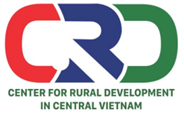
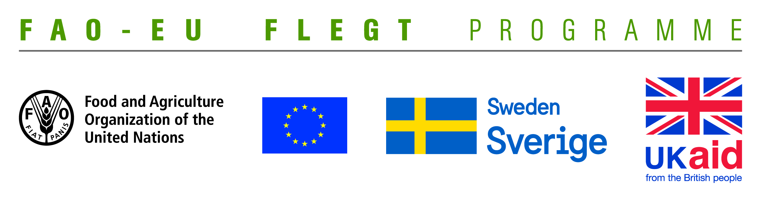

TERMS OF REFERENCE (TOR)
Project name | Supporting small business holders comply with the LD requirements in order to effectively participate in national and global legal timber supply chains
Job Title | Forestry Specialist
Contracting Organization | Centre for Rural Development in Central Vietnam (CRD)
Location | Thua Thien Hue
Time | From May 2018 to September 2019

- Background information
The EU-FAO FLEGT Programme provides financial assistance for the implementation of Voluntary Partnership Agreement on Forest Law Enforcement, Governance and Trade (VPA/FLEGT) in the countries. This programme aims improving forest management and protection, capacity building and technical support through projects in forestry area. The EU-FAO FLEGT Programme supports Vietnam ondeveloping Vietnam Timber Legality Assurance System (VNTLAS),reinforcing the commitment of the wood processing industry in the regionto create a legal source of wood, harvest timber in a sustainable way and focusing on the capacity building activities for relevant agencies and stakeholders to implement effectively VPA/FLEGT agreements.
Centre for Rural Development in Central Vietnam (CRD) implements the project titled “Supporting small business holders comply with the LD requirements in order to effectively participate in national and global legal timber supply chains” funded by the Food and Agriculture Organization of the United Nations (FAO). The project aims supporting small business holders to comply with the legal requirements, Vietnam Timber Legality Assurance System and Organizations Classification System requirements in order to effectively participate in national and global legal timber supply chains. Under the project, CRD will coordinate with Center for Education and Development (CED),Center for People and Environment (COPE) and other local partner organizations including: Forestry management agencies, Timber Association and other civil social organizations (CSOs) to implement activities in Quang Tri and Dong Nai Provinceand produce, achieve or deliver the following outcomes:
Outcome 1: Rapid assesment for better understanding of capacity building needs of local stakeholders at provincial level conducted and assessment methodology validated.
Outcome 2: Capacity of CSOs and other local partner organizations to provide targeted technical support to micro-enterprises for Legality Definition compliance strengthened and tested.
Outcome 3: CSOs and local associations have the capacity to undertake independent/participatory monitoring of VNTLAS OCS implementation.
Outcome 4: Monitoring, evaluation and visibility framework developed.
To implement the proposed activities under the project, CRD is currently looking for a Forestry Specialist to work on part-time basis (02 days per month on total 18 months). The successful candidate will report to the Project team leader and work with CRD’s team.
- Qualification and competencies required
- At least Master degree in forestry, social forestry, forestry business or related fields.
- At least 5 years of working experience in forestry, timber trade, and social monitoring; experience in working with wood processing enterprise is preferable.
- Good knowledge on VPA/FLEGT, forestry related laws and related issues
- Good skills to promote and operate group discussions.
- Good skills to analyze, synthesize information and write reports.
- Ability to work independently and in a team.
- Excellent verbal and written communication skills in both English and Vietnamese.
- Overall responsibilities
- Provide technical support and advice for designing and finalizing the needs assessment, including reviewing tools and methods
- Develop some documents such as training materials, policy briefs and social monitoring strategy requested under the project
- Play an active role in improving the understanding of VPA/FLEGT, forest governance, organization classification system and social monitoring for local partners and the CRD project team
- Review and edit documents and materials developed under the project
- Review reports and documents as needed to ensure that it sounds professional and relevant for the business sector and other stakeholders
- Develop good collaborative relationships with relevant project stakeholders (including relevant governmental agencies, organizations in the VNGO-FLEGT networks, forestry experts, etc)
- Provide technical support for the project team and consultants
- Perform other related work as required by the Project team leader
Interested candidates are invited to send CVs via email no later than 21 May, 2018: namnv@crdvietnam.org with cc hoangtq@crdvietnam.org and huongnl@crdvietnam.org

